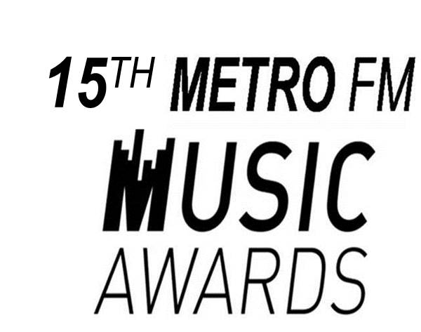

METRO FM MUSIC AWARDS SUBMISSION FORM

BEST URBAN GOSPEL ALBUM

NAME OF ARTIST/GROUP

ALBUM TITLE

RELEASE DATE

CONTACT INFORMATION (ARTIST/AGENT/MANAGER)

NAME

RECORD COMPANY

ADDRESS

TELEPHONE

E-MAIL ADDRESS

WEBSITE

NB: THIS FORM INCLUDING 4 CD COPIES OF THE NOMINATED ARTISTS/GROUPS MUST BE HAND DELIVERED TO THE ADDRESS BELOW:

METRO FM MUSIC AWARDS

METRO FM Office 826

8TH FLOOR – SABC RADIO PARK

HENLEY ROAD

AUCKLAND PARK, 2006

